Datacenter Solution

We design and deliver end-to-end network solutions for all types of data centers.

The vast impact of the Internet, Cloud Computing, Internet of Things and Artificial Intelligence in the last decade has had a dramatic impact on data center scale, design and connectivity.

KONNEC provide the answer to your evolving data center network, building and delivering advanced, scalable network infrastructure solutions.

Flexible in approach, KONNECT design network solutions to meet the demands of any data center build, Colocation, Enterprise, or Telecom. We listen to our customers to help create data center solutions that meet their exact requirement.

KONNECT have a comprehensive platform of configurable fiber and copper connectivity solutions, designed to increase bandwidth, migrate easily, expand capacity, maximize space, offer great economy, and allow rapid deployments.

With decades of expertise in the design and manufacture of network solutions, we have the capabilities and infrastructure to rapidly deliver pioneering network connectivity solutions across the globe.

Data centers are an integral part of most businesses. As companies expand, the question of whether to keep running your own data center or use a colocation facility needs to be addressed. Company expansion almost always results in an increase in cooling and electricity bills for their servers, which sometimes doesn’t fit within their budget.

In-House Hosting – In-house hosting refers to servers and networking hardware that is owned by the company and is controlled on the company premises or at their own stand-alone data center location.

Dedicated Server – say you want some type of IT in any country or city, Buying a dedicated server from a dedicated server provider is a way for you to get the tech you need without all the hassle of setting everything up yourself.

Colocation – is the use of a separate data center as a shared facility. A company’s data is stored and managed offsite by a colocation provider along with data from other companies as well.

Managed Hosting – is the use of a data center, but a company is assigned their own dedicated servers or cloud servers.

Advantages of Colocation and Outsourcing

There are many reasons to use a colocation facility or an outsourced data center. Using a shared colocation facility can reduce a company’s cost for cooling and power. Colocation companies can usually get a better deal from Internet providers than a single company can.
Other advantages of colocation and outsourcing include. Lower costs of IT, added resources for your servers, have added specific IT professionals that solely manage servers, and a predictable monthly or yearly cost, more security, more support, and free maintenance.
Colocation facilities can also offer redundant power and Internet connectivity, which can assist with maximizing uptime. Colocation providers and data centers are also readier for a power outage and a disaster than the average businesses. Most facilities also provide superior security features, which many in-house data centers cannot.

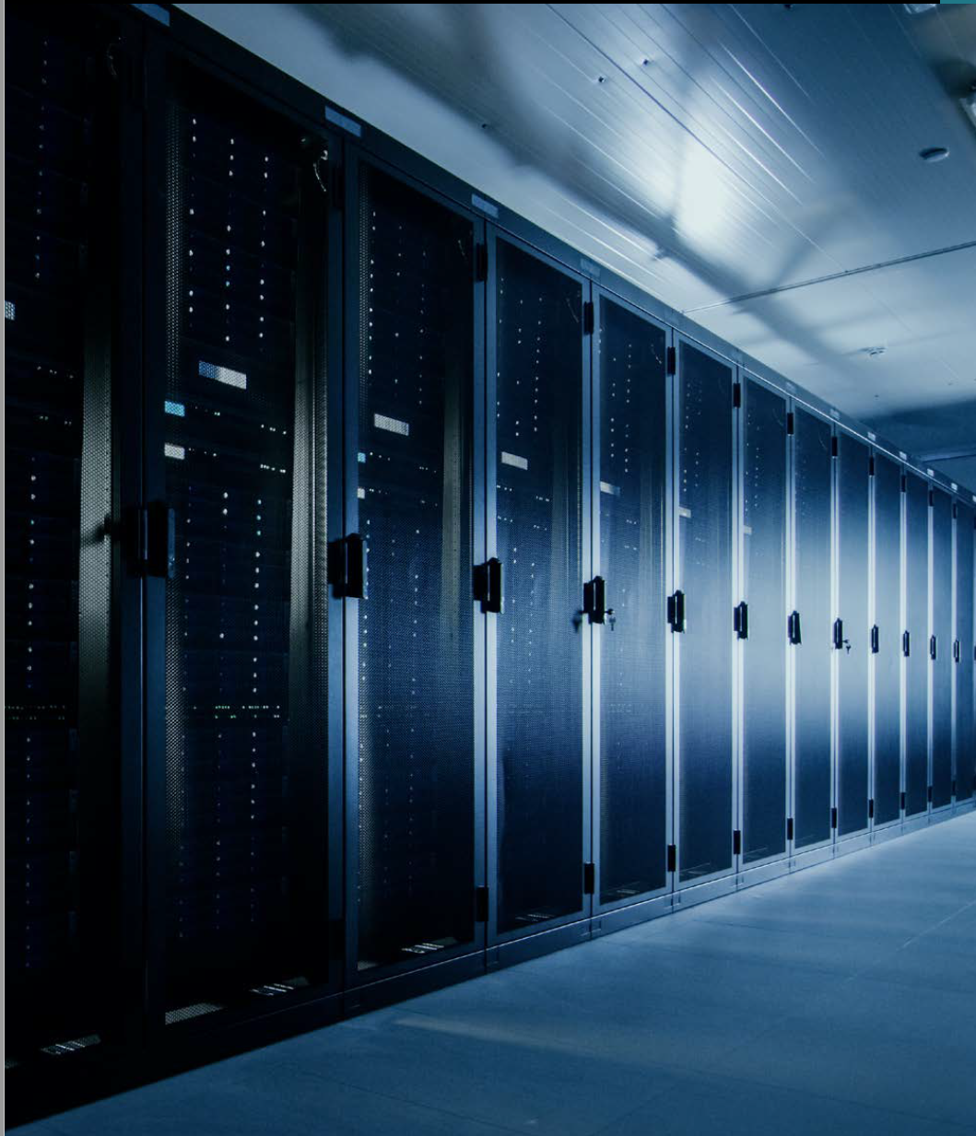

Datacenter Architectures

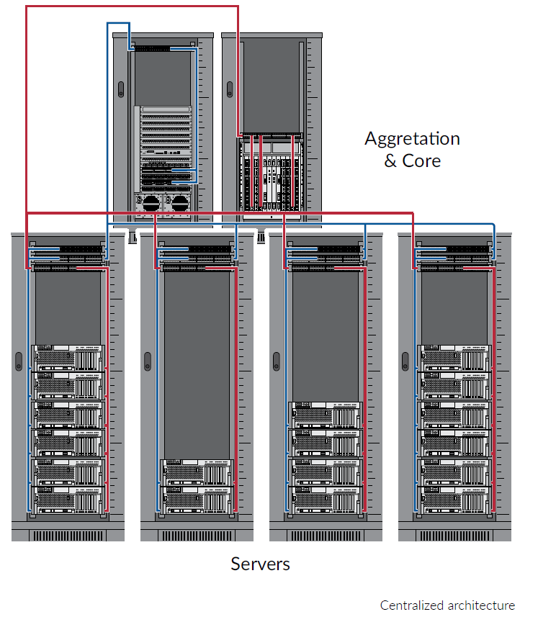
Data center networking architecture —the layout of the cabling infrastructure and the way servers are connected to switches must strike a balance between reliability, performance, agility, scalability and cost. To optimize the data center investment, the architecture must also offer the ability to support both current and future applications and speeds.

The centralized network architecture is an appropriate model for smaller datacenters of less than 500 m2. There are separate IP and SAN networks and each one leads from the servers to the core switches which are centralized in the main distributor.

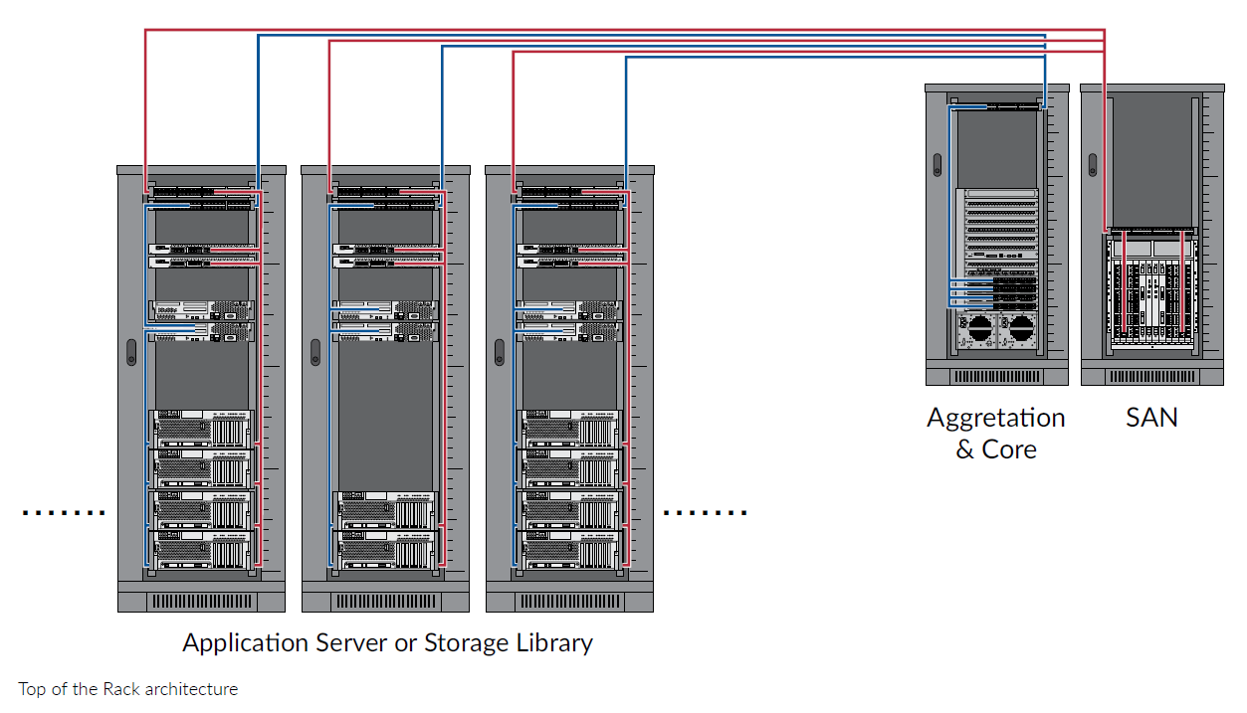
The zoned network architecture consists of distributed switches. As depicted below, the switches can be distributed in an end-of-row (EoR) or middle-of-row (MoR) model. In these cases, the cabinet rows are opened into a star pattern. Switches sit in one cabinet and route data cables from that point to servers within the cabinet rows. This architecture is very scalable and repeatable. It reduces the number of network devices and improves the port utilization of the network. Zoned architecture is usually the most cost-effective, providing the best trade-off between switch port utilization and cabling costs
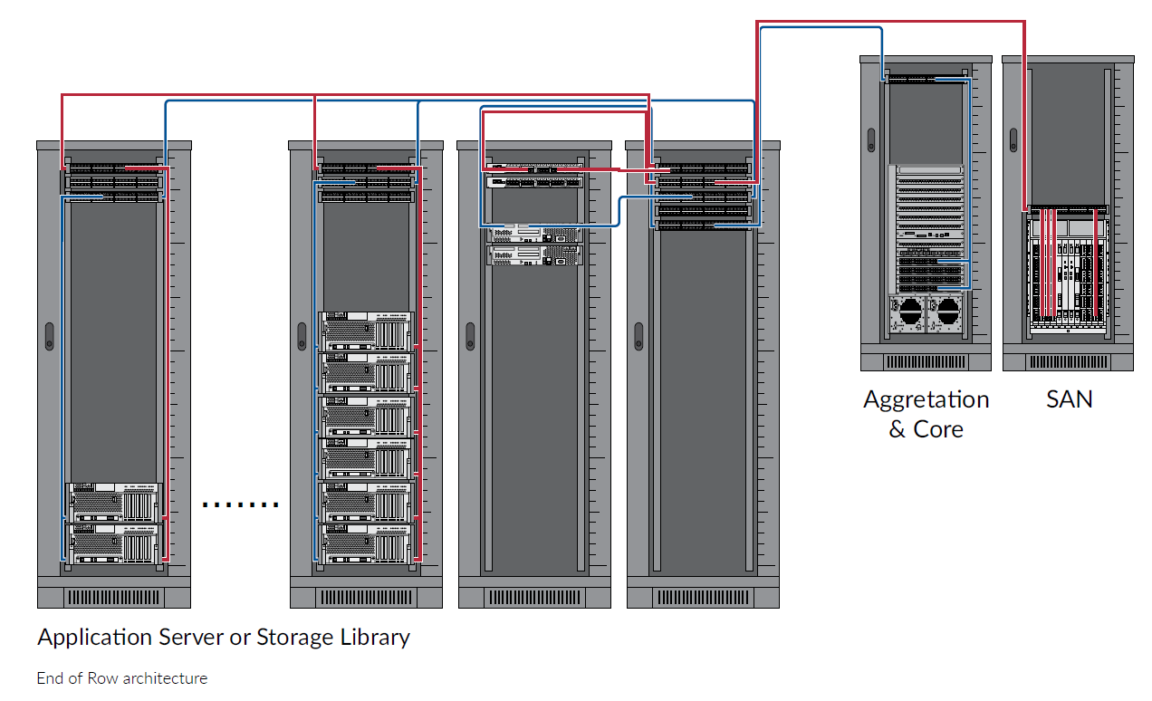

Distributed switching typically consists of at least two switches in each server cabinet. This networking concept is also known as top-of-rack (ToR) switching. A ToR switch is installed in the top of racks as access or leaf switch. All servers in a rack are cabled to both switches for redundancy. The ToR switches have uplinks to the next switching layer – aggregation or spine switches as shown below.

