“CURRICULAM VITAE”

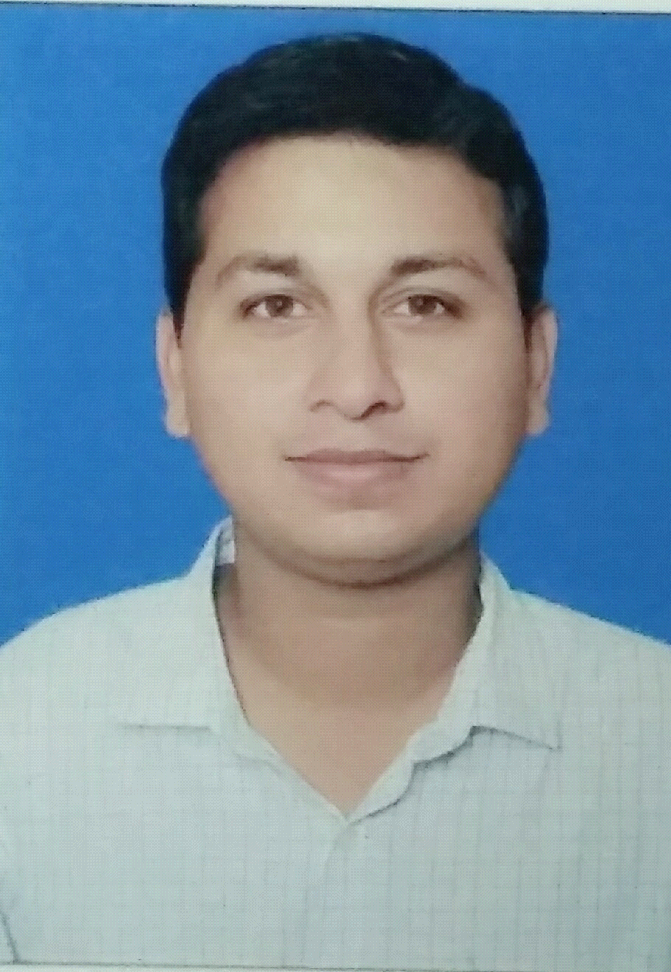
Room no.  B/57, Sector-3
Near Airoli Railway Station.
Airoli, Navi Mumbai  400708
E-mail: dts_quest@yahoo.co.in
Mob.: +918451034483

TUSHAR S. DAINE

DATE OF BIRTH : 8th SEPT 1985

GENDER : Male

NATIONALITY : Indian

PASSPORT NO. : N9665621

LANGUAGES KNOWN : English, Hindi, Marathi and Arabic

Educational Qualification : B.Sci [Chemistry]

Work EXPERIENCE: -

1] As an QC- Chemist in Padmaja Laboratories, T.T.C. Industrial Area, Navi Mumbai from the December 2006 till December 2007.
Job description :-
Raw Material such as packing material , solvents testing both physical and instrument way
Finish Good testing work using Acid-Base Titration & Refractive Index
Preapring Standard Solutions , Calibration of Instrument and Maintaining Test Records .

2] As Trainee R&D-Chemist in S. I Group(Herdillia), Opp.Juinagar Rly.Stn., Navi Mumbai for a month of May-2007.
Job description :-
As an Intern Chemist running Pilot Plant of R&D product under Guidance of Docterate Senior Executives alongwith training for GAS CHROMATOGRAPHY [THERMO FISCHER GC 8610] both Theoretical and Practical way .

3] As a Team-member of Safety Management and Spot analysis team of SIRA PVT.LTD. Panvel from 17 Nov.2009 up till Oct.-2010 [Chemical Industry Insurance analysis related job]

4] As Trainee Lab-Analyst in Metallurgical Product India Pvt.Ltd.(MPIL), Taloja, M.I.D.C, Panvel. From 13 Jan.2011 To 25 Mar.2011.
Job description :-
Raw Material testing by titration methods and preparing standard solutions
Calibration of pH-meter , weighing balance , Ion meter and ICP instrument
Preparing Diluted Samples of Finish Good Sample powder for further Ion meter and ICP.

5] As QC-Chemist in Castrol India Ltd. [Patalganga unit] From 14 April 2011. To 11 Feb. 2013
Job description :-
All Sought of quality testing work for Packaging , Raw Material and Finish Good Materials
Packaging material like Cans-Caps , Buckets , Drums , Label Stickers , Cartons checking
Physical Parameter like appearance , density and viscosity of Base Oil & Lubricants testing
Blended Finish Good Products' Physical parameter like appearance , viscosity , flash point ,
Moisture test & Instrumental analysis for density , cold cranking simulation , pour point ,
Elemental Analysis on XRF instrument & Auto-titrator for Total Base Number was handled
Calibaration of Instruments alongwith Housekeeping on Daily Basis
Besides Maintaining Records both on Paper and in System through ERP for Organisation .
Also train and work for Safety and Health Hazards alongwith First Aid System in the firm .

6] As QC-Controller in TYTAN Organics Pvt. Ltd. [ Hamriyah Free Zone-1, Sharjah, UAE] from 15 July 2013 up till 22 July 2015.
Job description :-
Daily Basis Utility sample ,i.e, Water Sample was to be analysed in which pH , TDS and
Hanna testing kit used for checking free chlorine , Iron , turbity and various elements test
Titrations testing were carried so Standard solution of 0.5N NaOH and 0.5N HCL & buffer
solution for pH meter and indicator solution has to be prepared .
Raw materials Sublimation test n Crystallation Point , Tar Content , Viscosity , SG test .
Finsih Good material all physical paramater like pH , Viscosity and Specific Gravity check
alongwith % Solid Content [ by Oven and Instrument method ] .
% Salt Content using 0.01M Lead Nitrate and Dithiazone indicator of FG product .
Hydrometer as well as Piknometer and Centrifuge Machine was also in use for Lab work
Concrete Performance test ,i.e., for slump and spread test for produced redymix product .
Maintaining Test Records , System entry and MSDS of all products were kept in Updates .

7] As Laboratory Technician in Al Majwal Factory for Oxidized Asphalt in Dammam 2nd Industrial Area, Saudi Arabia [ from 22 October 2015 up till 22nd October 2017]
Job description :-
As Laboratory Incharge and an Asistant to Process Manager executed both in plant
and Laboratory for job assignment of 2 years.
All Physical Parameters of Asphalt and Cutback product like Viscosity , Penetration ,
Ductility , Moisture , Specific Gravity , pH , Appearance , Drying Time check .
Polymerised Asphalt product MESENZZA Machine was able to operate and process
in Plant alongwith its testing on Instrument MALVERN KINEXUS LAB +
All instrument Callibration was on Monthly Basis and all records were maintained.
MSDS and all Health and Safety Concern was in Execution in Plant and Laboratory .

8] As Laboratory Assistant in Qatar Petroleum Refinery in Masseid Industrial City , Doha ,
Qatar from 27 November 2018 uptill 30 May 2019
Job description :-
Daily Basis Sampling work of fuel Tanks ,LPG Gas Samples ,Utility samples .
On field Testing H2S gas HCL and Organic Chlorides using Drager Test.
Keeping Records and Preservation of Samples .
Assisting Laboratory Technician in Internal Testing Activities.

9] At present as Laboratory Analyst in ANI Services ltd. to client HPCL Lube Oil Plant , Silvassa(Dadra Nagar Haveli union territory).
Job description :-
Laboratory Sample testing of Lube Oil blend , Base oil raw material and Grease product .

DAY TO DAY ACTIVITIES under-taken in JOB: -
 Sample analysis and report generation
 Maintaining sample database
 Use of Web to share reports
 Provide Trend analysis update
 Competitor samples, compatibility reporting and providing comparative reports /
recommendation as required to be in updated stage in Process
 To support Technology team in the testing of raw materials/ finished products/ lab blends
 Use and upkeep of lab/ performance test equipment’s for projects and customer services
 Ensure timely calibration and updated records
 Manage stocks of chemicals and consumables in the lab. Ensure timely replenishment
 Ensure timely disposal of samples as per protocol
 Ensure housekeeping standards in lab

Instruments handled for analysis
- Moisture Analyzer
- MALVERN KINEXUS LAB + for PMB Product
- Ductility meter
- Density Meter ( ANTON PAAR DMA 4500)
- Penetrometer
- Pour point instrument
- Penesky Martin Flash point apparatus [Manual as well as Auto]
- Manually Viscometer [ kinematic as well as rotational]
- XRF (X-Ray Fluorescence)
- Thermoelectric Cold Cranking Simulator
- Auto-Titrator for TBN Analysis
- Refractometer for Spotting Refractive Index of Additive Sample.
- Mini-AV X Auto viscometer [ Kinematic]
- Brookfield Auto viscometer [ Rotational]
- All tests are done as per ASTM (American Standards of Testing & Material) and AASHTO (American Association of State Highway and Transportation Official).

Expectation from the JOB: -
Resourceful Job Work as per to gain valuable knowledge and experience with regards to professional aspects.
Thanks,

Tushar Sham Daine

