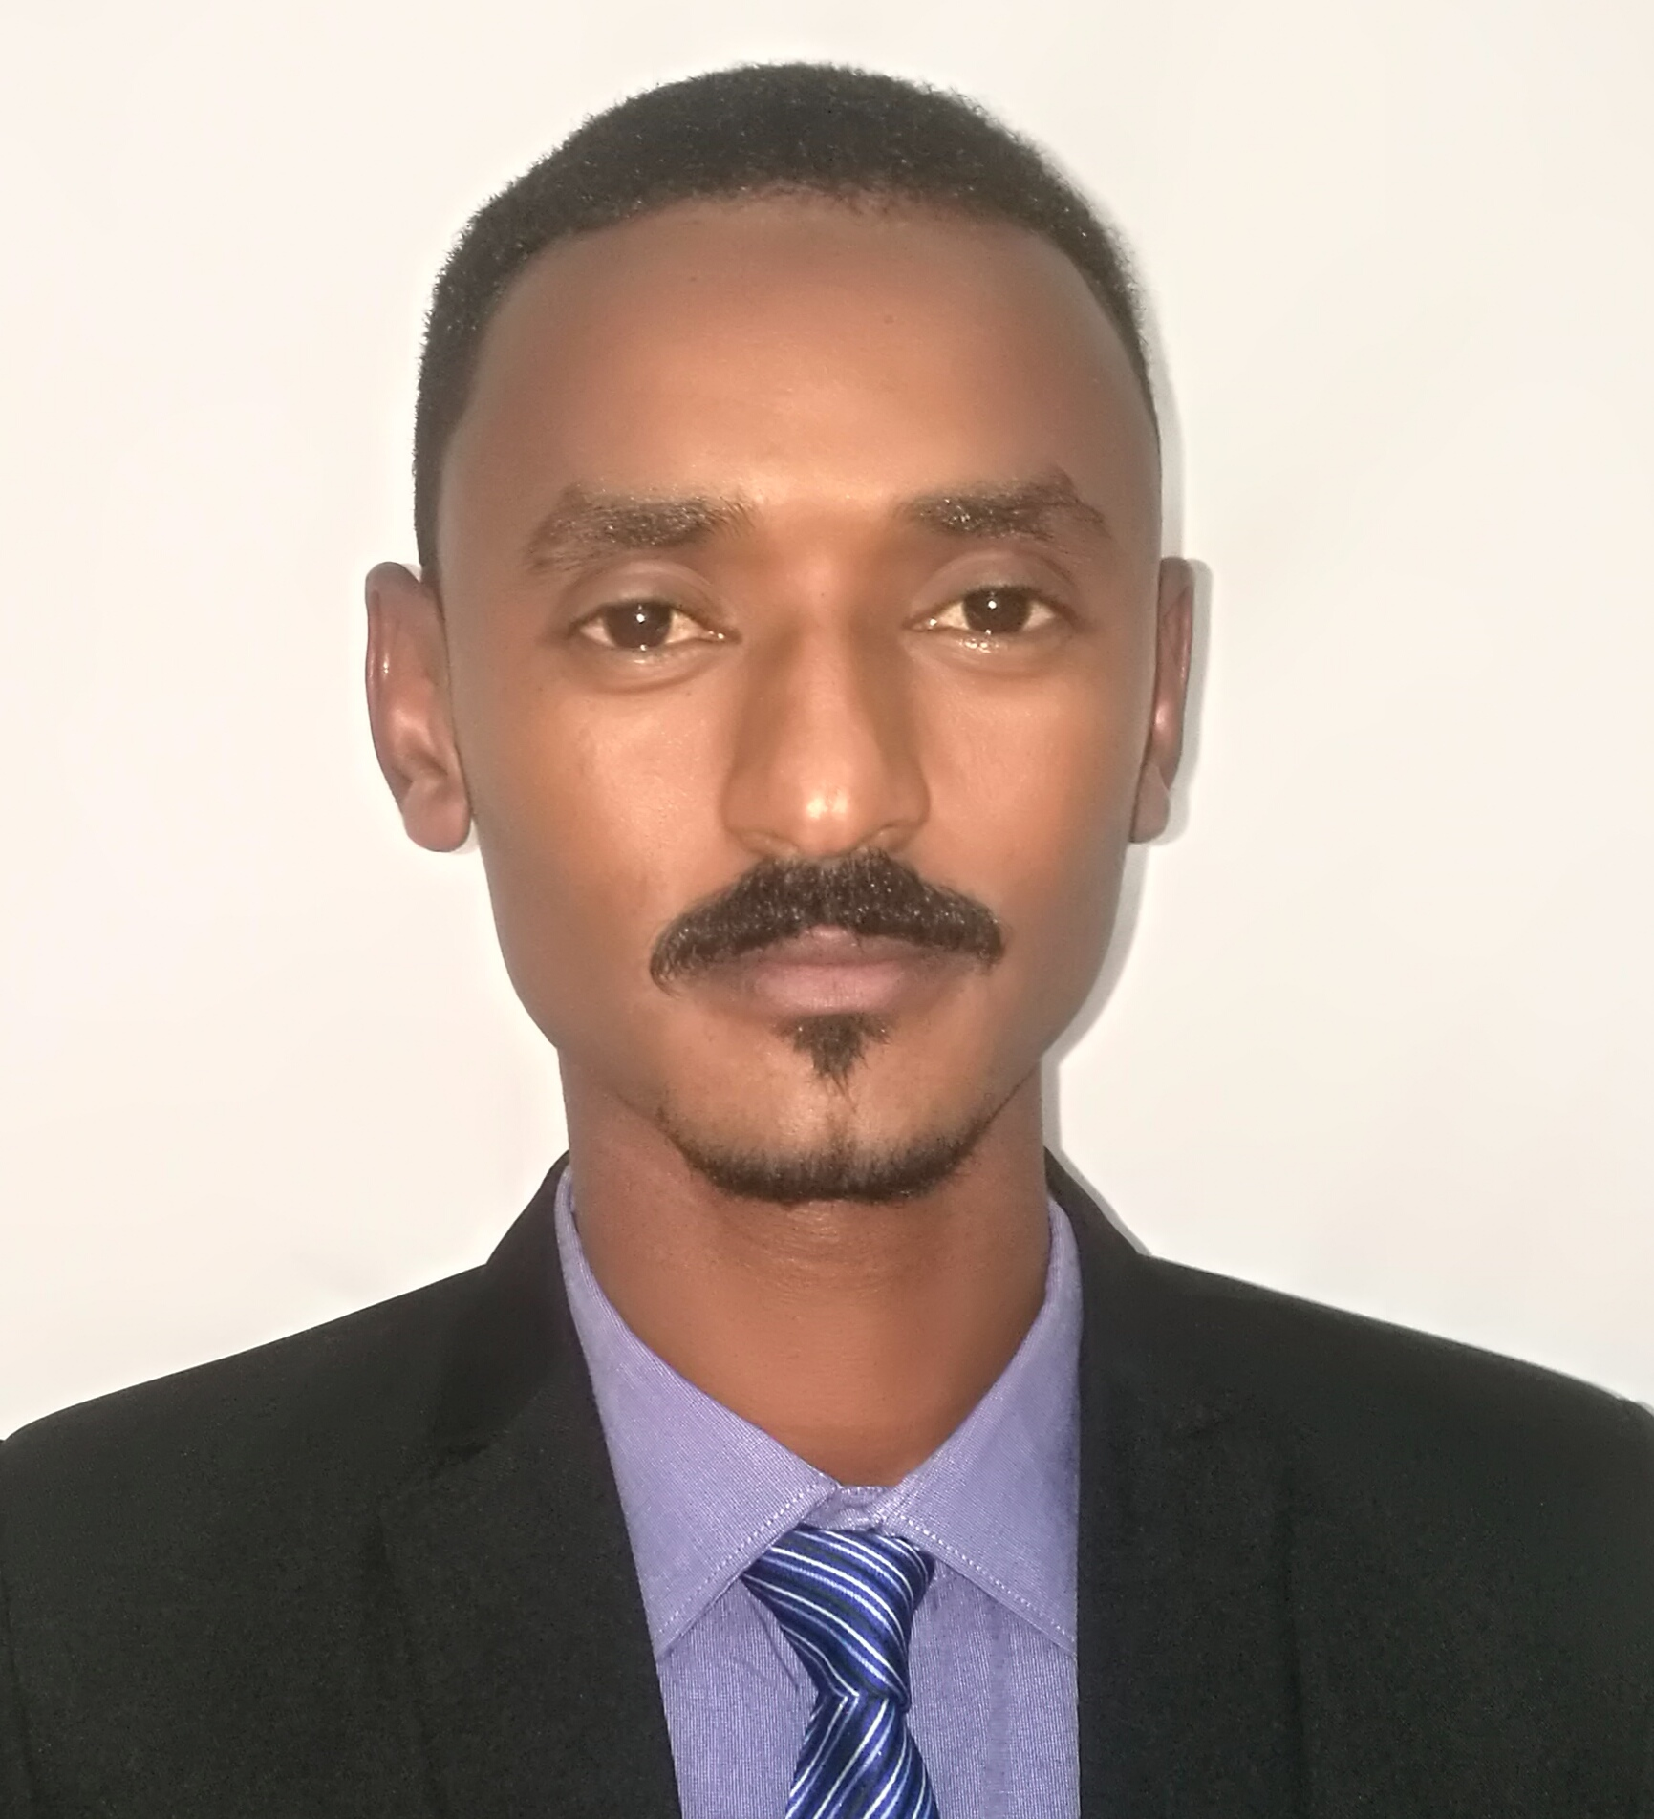

CONTACT
Mobile : +249912275469
Home : +249118883350
E-mail : altayebosman.78@gmail.com
Address: Sudan, Kenana
CAREER OBJECTIVE:
Challenge, commitment and job satisfaction are keywords for me, since I have been into the Quality control and Assurance department for over 6 years. I am looking for a challenging position, where can utilize my experience in managing laboratories and analytical techniques of chemistry ,which can putt in dynamic organization. Where there is need to share broad co-operative efforts through sound planning and creativity for all round development of company with constrain professional way.

EUDCATION
University : Omdurman Islamic University
College : Faculty of science & Technology
Specialization : B.Sc. in Chemistry
Graduation year : 18 June 2012 (A.D)
Graduation Grade : Very Good

SKILLS
Language's: Arabic( Native) /English (V.Good)
Computer: Diploma in computer, Basic& Advance Excel
Personal Skills:
1. Strong analytical skills, combined with effective, communication, organization and planning ability
2. Ability to work with team
3. The ability to work under pressure
4. The ability to solve problems smoothly
5. to continuously develop the organization through self-development and search for what is new in my field

.PERSONAL DATA
Date of birth : April 24, 1991
Nationality : Sudanese
Marital Status : Single
Gender : Male

Altayeb Osman Bushara Mohamad

Chemist Quality Control

EXPERIENCE (6 years)
Chemist Quality Control, Fuel Oil & Lubricant's laboratories
Kenana Sugar Company Ltd.
July 2014 present ( 6 years )
- Carry out all routines analysis using (ASTM & ISO & DIN EN Method)
- Carry out the following test :- Viscosity @ 50$℃$ , Density @ 35$℃$ , Flash Point, Upper Pour Point, Water Content, Sulfur Content, Color, Ash Content, Copper Corrosion, Estimated Cetane Number etc...
- preparing and co-coordinating the internal audit for laboratory and make sure the laboratory management system ISO/IEC 17025 are apply in lab
- Daily checking and adjustment of lab instruments
- Recording and evaluating the analysis results
- Request reagents & needed instruments for lab
- Ensure all samples are taken and prepared correctly
- Ensure tests are done on time
- Evaluate the effectiveness of the analysis
- Controlling the documents issued by the lab
- Verify test procedures to ensure use of the updated and validated test methods
- Supervision, training and ensure staff are working in a safe environment and that safety procedures are followed at all times
- Co-ordinate with process in charge, marketing and store house department.
- Manage the laboratory and prepare the required daily and monthly reports and prepare some reports requested by the manager of Quality Control
- Prepare Annual budget for Chemical and other requirements of Laboratory equipment's and Reagents
- performs other duties as assigned

Chemist, Petroleum Laboratory
The Central Laboratory For Technical Service & Calibration (CLTSC)
September 2017 to October 2017 (1 month)
- Training for carry out all analysis fuel oil and lubricants oil and transformer oil Using ASTM and ISO methods
- Training for how to deal with chemical device's
- Training for carry out laboratory management system ISO/IES 17025 and occupational health and safety management system OHSAS 18001

PROFESSIONAL COURSE'S
- General Requirements for the Competence of testing & Calibration Laboratories ISO/IEC 17025 African International Center for Quality Management Systems, 02-08 /September 2019 (30 hours)
- Laboratory Management System ISO/IEC 17025 (Awareness, Documentation, Internal Audit)
7Vision for Training & Development 23-26 September 2017
- Total Quality Management (TQM)
ESTIDAMA Energy & Mining Training Center, 08-12 March 2015 (20 hours)
- Professional Mini Master Degree in ISO Fundamental's and Internal Audit
American Board for Management and Human Rescores, 05 February 2018 Certificate No: 1445
- The Professional Diploma in Occupational Safety & Healthy Administration (OSHA)
American Board for Management and Human Rescores, 12 October 2017 Certificate No: 1119
- Health Safety & Environment Fundamentals (HSE)
ESTIDAMA Energy & Mining Training Center, 04-06 February 2015 (12 hours)
- ISO 9001 : 2015 (Awareness, Documentation, Internal Audit)
7Vision for Training & Development 07-12 April 2018
- Fire Fighting Equipment's and Control
ESTIDAMA Energy & Mining Training Center, 07-10 February 2015 (16 hours)
- The National Examination Board in Occupational Safety and Healthy (NEBOSH)
7Vision for Training & Development 25-27 September 2018
- Occupational Health and Safety Management System (OHASA 18001)
7Vision for Training & Development 02-05 October 2017
- Continual Improvement, Quality Assurance Which Include Titles bellow:-
- Kaizen Foundation 2. 5S 3. Six Sigma
7Vision for Training & Development 07-09 October 2017

222

