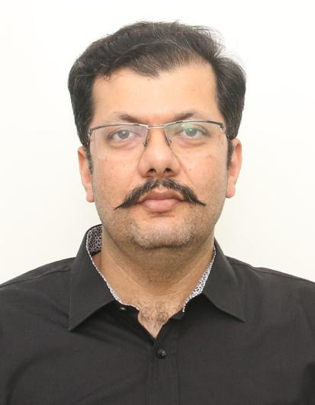
Ahmed Shahzad
ranjha_73@hotmail.com | +92-300-7640070/+92-321-4540270 | Islamabad, PK
Personal details: Male | Pakistani | Married | Sep 30, 1981

Sales Management Professional – Oil & Gas Industry
Buisness-savvy and accomplished professional with 15+ years of experience in B2B and B2C sales growth and business development within in the oil and gas industry. Proven track record of driving revenue growth and exceeding sales targets. Demonstrated success in leading cross-functional sales teams to deliver outstanding results, while developing innovative proposals that generate new business opportunities. Skilled in devising technical sales strategies, streamlining cash processes, and redesigning company procedures to improve efficiency. A proactive leader, taking ownership and responsibility, while fostering strong relationships with clients. Strong background in credit control, customer base growth, and product promotion across multiple market segments.
Areas of Expertise
- Sales & Revenue Growth
- Relationship Management
- Sales Team Leadership
- Financial Management
- Performance Enhancement
- Technical Sales Strategy
- Process Improvement
- Account Management
- Excellent Communication
- Techno-Commercial
PROFESSIONAL EXPERIENCE
Total Parco Pakistan Ltd. (Multinational - Oil & Energy Company) 2017 – Present
Regional Manager (Islamabad) - B2B & B2C Sales
Direct B2B and B2C sales in lubricant divisions, specifically for Textile, Cement plant, and Corporate sectors. Address customer queries and complaints in a professional and technically sound manner, building trust and credibility with clients. Deliver proactive leadership and take responsibility in customer/account team environments to gain credibility with clients and define technical sales strategies for complex opportunities.
Selected Accomplishments:
- Earned multiple promotions and became Regional Manager – Islamabad for delivering exceptional performance.
- Consistently accomplished targets and achieved outstanding ratings throughout the employment.
- Redesigned effective Company procedures, and ensured successful credit control and cash flow generation.
- Maximized customer base by adding 5-10 potential customers annually, promoting Company products across all active segments in the assigned area.
- Attained the highest revenue and volume in 2022, generating RS 153M in the Islamabad industrial market and 1282 MT of lubricants, the highest ever in Total Parco's history.
- Proposed need-based solutions to management for specific customers, based on customer volume and strength.
- Drove business growth by evaluating market dynamics and developing winning proposals.
ADDITIONAL EXPERIENCE
Total Oil Pakistan (Now Total Parco Pakistan Ltd):
Senior Sales Area Manager, Islamabad | 2014 – 2017
Area Manager, Islamabad | 2013- 2014
Territory Manager, Faisalabad | 2010 – 2013
Zone Manager, Sargodha | 2008 – 2010
Industrial Sales Executive, Gujranwala | 2006 – 2008
EDUCATION
MBA Executive, University of Sargodha | 2010
BSC – Chemical Engineering, University of Engineering & Technology Lahore | 2004
TRAINING
Certificate of Participation – Building High-performance Team, Total Parco Pakistan Ltd | 2022
Certificate of Participation – Stakeholder Management, Total Parco Pakistan Ltd | 2022
Certificate of Participation – Essentials of Leadership, Total Parco Pakistan Ltd | 2018
Attended 5 days of International Training on Cement Industry, Bangkok | 2017
Attended 5 days of International Training on Lubricants Industry, Bangkok | 2016
Lubricant Sales Training, Total Oil Pakistan | 2014
Communication and Selling Skills Training, IMS Knowledge | 2013
Business Helicopter & Brilliance on Basics Training, Octara | 2012
Team & Business Management Training, Octara | 2011
30 days technical course on Development of Process Plant Operational Skills, Centre for Professional Excellence
MEMBERSHIP
Member of Pakistan Engineering Council, Islamabad
TECHNICAL PROFICIENCIES
Microsoft Office | Applications to many Computer-aided Software

