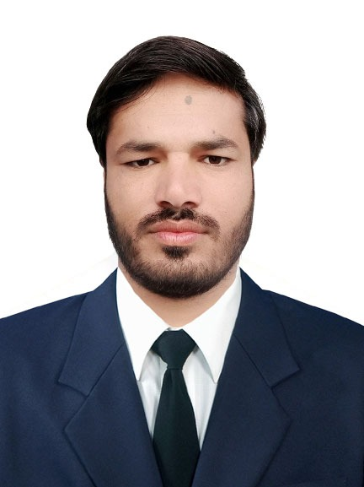
Location Industrial Area 3 Sharjah
Cell +971542030992 Visa status. Visit
Naseem_khan@live.com

NASEEM ULLAH KHAN KHATTAK
Objective. |  | Seeking a position to utilize my skills and abilities in the Information Technology and other Industry that offers professional growth while being resourceful, innovative and flexible. Good communicator with sound judgment, keen eye to detail and flexible nature.
Skills & Abilities |  | - Demonstrated analytical, problem-solving, organizational, interpersonal, communication skills and time management skills  - Strong hands-on management capabilities, leadership, coaching, and people management skills  - Demonstrated leadership skills, leading clients thru successful implementations, previous employers thru profitable growth and peers thru thought leadership  - Excellent communication skills (written and oral)  - Strong Microsoft Office skills advance excel reporting, data filtering, pivot etc.  - Strong project management skills, such as creating and managing project plans and cost benefit analysis  - Quick learner, adjustable, punctual, team leader skills.
Experience  Responsibility  ¹ |  | Business Manager 1st June 2021 – 29 Feb 2024  Waves Plus PAKISTAN LTD.  - Monitoring the sales team & sale goals  - Conduct or participate in team sales meetings  - Assist Branch Manager with Performance Evaluations  - Establishing ‘Performance Improvement Plans’ (PIPs) for sales team members that are under performing  - Disciplinary recommendations and participation in disciplinary sessions  - Support the daily sales efforts of assigned Assistant Manager Store. Observe, coach and recognize the sales force in the successful marketing of HomeStreet’s products and brand. Ensure all staff are trained in sales and service techniques. Model sales skills and techniques as well as customer advocacy  IT SUPPORT OFFICER 19 February 2018 – 31st May 2021  SINGER Plus PAKISTAN LTD.  - Support ERP queries daily basis of teams  - Train new user and newly appointed Outlet Managers  - Install and configure computer hardware operating systems and applications  - Monitor and maintain computer systems and networks  - Talk staff or clients through a series of actions, either face-to-face or over the Phone, to help set up systems or resolve issues  - Troubleshoot system and network problems, diagnosing and solving hardware or software faults  - Replace parts as required  - Provide support, including procedural documentation and relevant reports  - Follow diagrams and written instructions to repair a fault or set up a system  - Support the roll-out of new applications  - Set up new users' accounts and profiles and` deal with password issues  - Respond within agreed time limits to call-outs  - Work continuously on a task until completion (or referral to third parties, if appropriate)  - Priorities and manage many open cases at one time  - Rapidly establish a good working relationship with customers and other professionals, such as software developers  - Test and evaluate new technology  Accountant March 2014 – 18 Feb, 2018  Ghaffar Corporation International Trading House.  - Preparing Balance Sheet daily and monthly.  - Making records of daily entries of exports and imports  - Preparing Bank book and cash book  - Responsible of all account matter  - Responsible for all bank matter and Letter of Credit  - Daily reconciliation entries.  - Manage daily petty cash and other expense.  - Manage daily opening & closing Entries.  - Daily reporting to Senior Accountant.  Admin Officer March, 2012 – 2014  Bashir Abdul Ghaffar overseas employment promoter.  - Excellent customer service skills that ensure client satisfaction with vacation packages and travel itineraries.  - Strong problem solving skills that allow me to handle even the most stressful of situations, such as stranded client’s hotels, and other travel emergencies.  - Develop the client intake form and interview processes that enhance the ability to understand client requirement and led to increase in customer satisfaction.  - Conducting interview and test for delegation.  - Preparing document for visa process and endorsement.  - Preparing documents for protector purpose.  - Visiting for different embassy for visa submission purpose.  - Booking ticket for selected and nominated candidates.
academic E0ducation |  | MIT (Information Technology)  PIMSAT Karachi  B.Com (Bachelor of Commerce)  FUUAST Of Karachi
COMPUTER skills |  | - MS OFFICE (Advance Excel Reporting Analyzing, Pivoting Dashboard)  - Web Development  - Networking (Advance Computer)  - Trouble shooting computer software & Hardware issu’s
Personal information |  | Father’s Name : Saif Ullah Khan  Date of Birth : 1st March, 1992  CNIC No. : 14202-8079278-1  Religion : Islam  Languages : Pashto, Urdu & English

